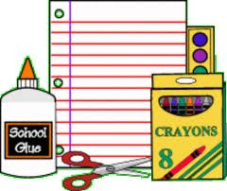**Southside Elementary**

**Second Grade**

**Supply List 2022-2023**

**1** scissors

**2** boxes of 24 count Crayola Crayons

**1** box of colored pencils

**4** glue sticks

**1** primary composition book (space to draw at the top)

**2** plastic folders (no prongs)

**1** 5 x 8 pencil box

**3** boxes pre-sharpened Ticonderoga pencils

**1** (2 pack) white rectangle eraser

**2** black Sharpies

**1** pair of headphones

**1** pack Expo Fine point dry erase markers (black)

**1** pack Expo Ultra Fine point markers (any color)

**2** box of tissues

**2** Lysol Wipes

**1** bottle of hand sanitizer